# Queries Output

Query A: - List each weekday (e.g. Monday, Tuesday…) and the total sales (qty * saleprice) for that day. The list must be in descending total sequence. Note: 7 rows should be listed by this query

**Paste result set from query here:**

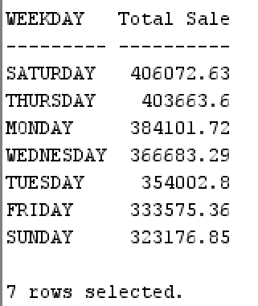

Query B: - List each customer category and the total sales (qty * saleprice).  
The list must be in ascending total sequence.

**Paste result set from query here:**

Query C: - List each product manufacturer and the total qty sold   
The list must be in descending total sequence.

**Paste result set from query here:**

Query D: - List the **top 10** customers based on total sales (qty * saleprice).  
The list must be in descending total sequence.

**Paste result set from query here:**

Query E: - List the bottom 10 products based on total qty sales   
The list must be in ascending total sequence.

**Paste result set from query here:**

Query F: - List the top city name based on total sales (qty * price) for each state  
The list must be in ascending state sequence.

**Paste result set from query here:**

